Data Analytical Assignment

1. Read data from HoustonCrime.csv, use the OBJECTID as the index. Drop records that have missing values in any of X, Y, Time_Begun, HPD_Division, Premise_Type or Zip_Code. Verify that you should have 8206 records. Convert Zip_Code into a String

2. Create a line chart with a title, markers, X and Y labels, a legend placed at the left bottom, for the numbers of theft cases based on dates

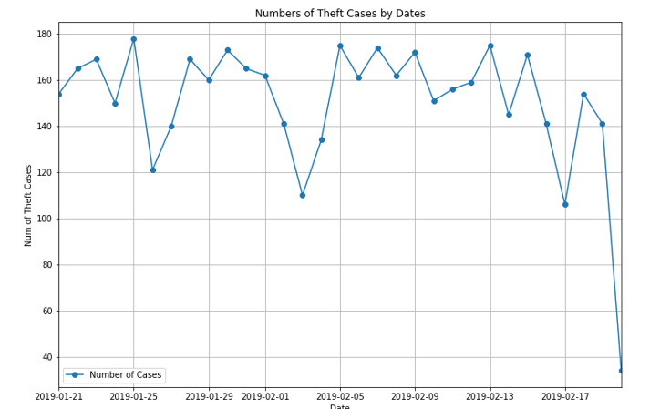

3. Write statements to answer: which HPD_Division has the largest number of crime cases (by all types)?

4. Create a BLUE bar chart of burglary cases based on zip code, including a bigger size title, X, Y labels.

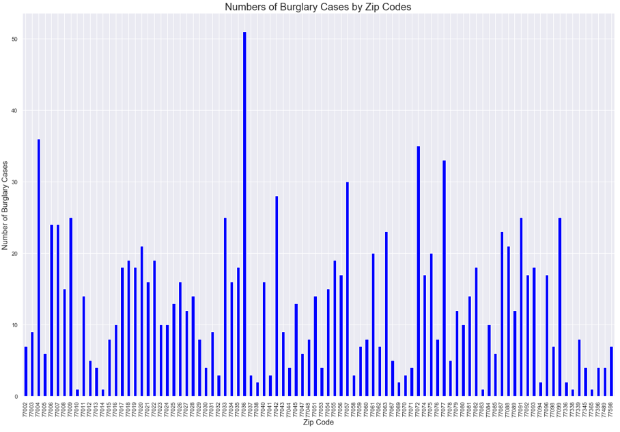

5. Create a heat map based on Premise Type and Offenses. Please answer the questions: what are the serious cases (offenses in premise types) you see from this chart?

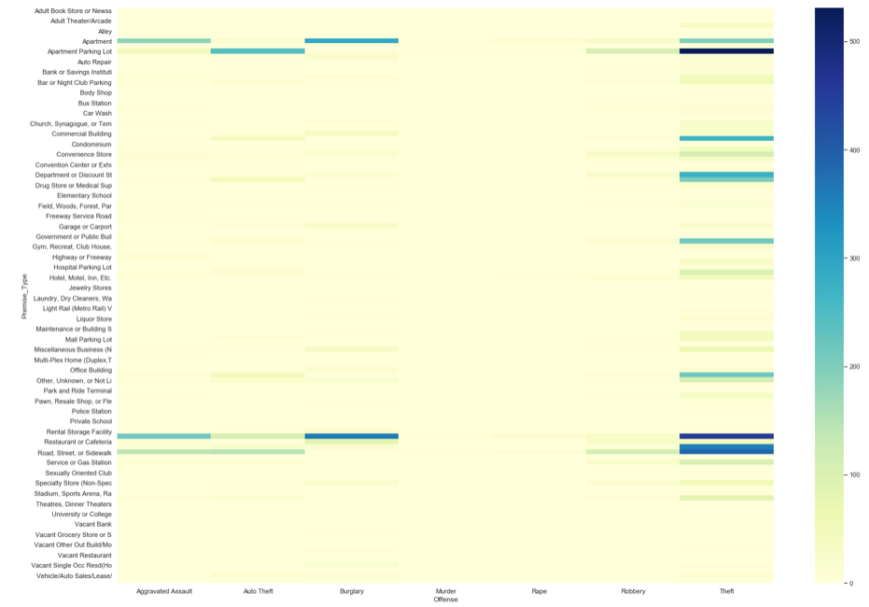

6. Create a heat map on Google map for all offenses

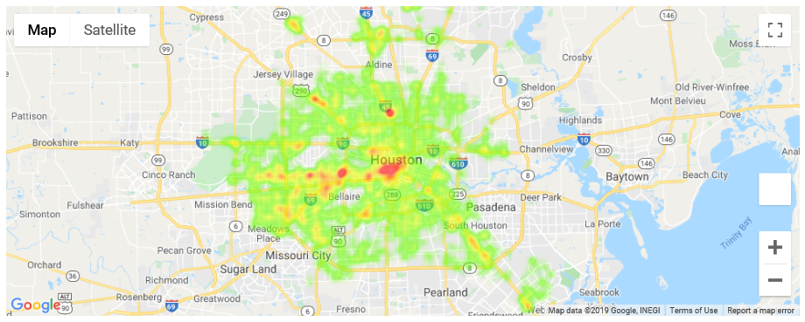

7. Create a heat map on Google map for murder cases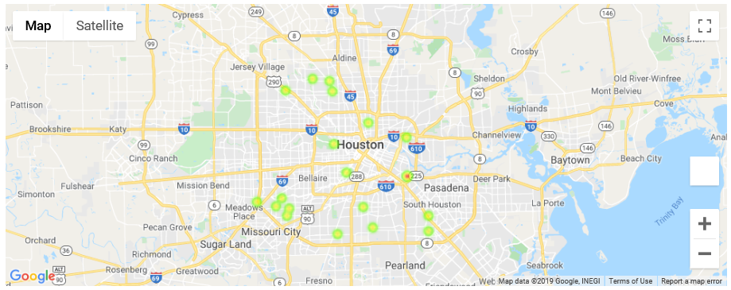

8. Create a stacked column chart based on HPD_Division and Offenses (different types)

